PHYSICS AND FORCES
Physics is the study of Energy and Forces.
Energy is the ability to do work.
A force is a ____________, ___________ or _________ on an object.
Examples | Picture | Pushing pulling or twisting force?
1 | 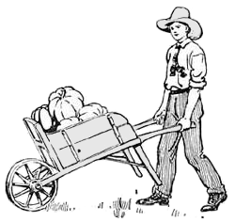
2 | 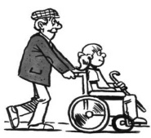
3 | 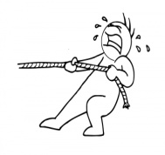
4 | 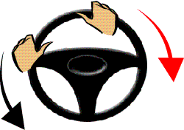
5 | 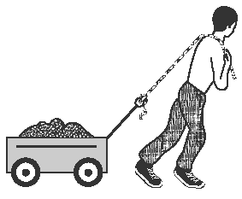
6 | 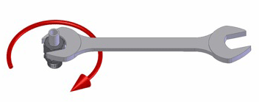
Forces can change the motion (movement) of an object.
Forces can make objects move faster= A______________.
Forces can make objects slow down or stop = D___________.
Forces can make an object change the d________ it is moving in.
Forces can make an object change shape.
Example | Picture | Are forces causing acceleration, deceleration, a change in direction or a change in shape?
1 | Man catches ball.  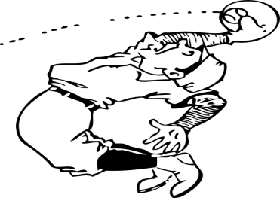
2 | 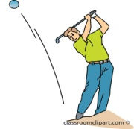
3 | 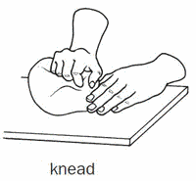
4 | Car speeds up.  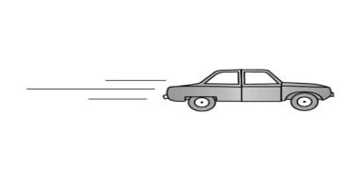
5 | A tennis ball hits the ground and is squashed. There are two changes here.  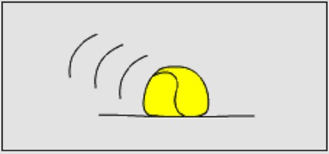
6 | Ball hits wall and bounces off. There are three changes here.  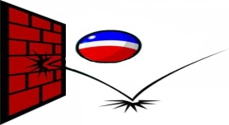

Force is measured in the units called N_____________ . The symbol N is used normally.

